**DAILY ONLINE ACTIVITIES SUMMARY**

|  |  |  |  |  |  |  |  |
| --- | --- | --- | --- | --- | --- | --- | --- |
| **Date:** | **04/01/2020** | | | | **Name:** | **Rohan VASHISTA BM** | |
| **Sem & Sec** | **6th Sem & B** | | | | **USN:** | **4AL17CS078** | |
| **Online Test Summary** | | | | | | | |
| **Subject** | | **OS IA-3** | | | | | |
| **Max. Marks** | | **30** | | **Score** | | **14(technical issues)** | |
| **Certification Course Summary** | | | | | | | |
| **Course** | **E-BOX** | | | | | | |
| **Certificate Provider** | | | **-** | **Duration** | | | **-** |
| **Coding Challenges** | | | | | | | |
|  | | | | | | | |
| **Status: completed** | | | | | | | |
| **Uploaded the report in Github** | | | | **yes** | | | |
| **If yes Repository name** | | | | <https://github.com/Rohanvasista/Coding-activities> | | | |
| **Uploaded the report in slack** | | | | **yes** | | | |

**Online test details**

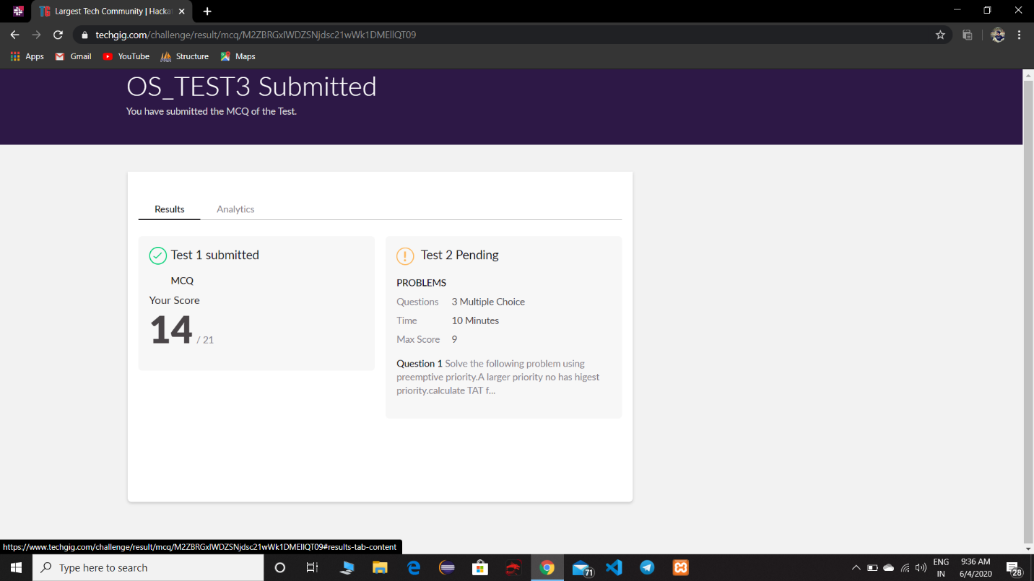

* Part2 I was not able to attend due to problem in interface.

**Coding Challenge Details**

